**Alarms Explanation**

**EPICS PV alarm values**

During the execution of the poemonitor IOC, many incidents can make the IOC unable to scan,update or write values on the PVs. Considering that, the IOC use EPICS alarms to signalize when any incident has occurred. Here follows a table showing all the possible alarm values generated for each PV by the IOC and it’s explanation of what causes it.

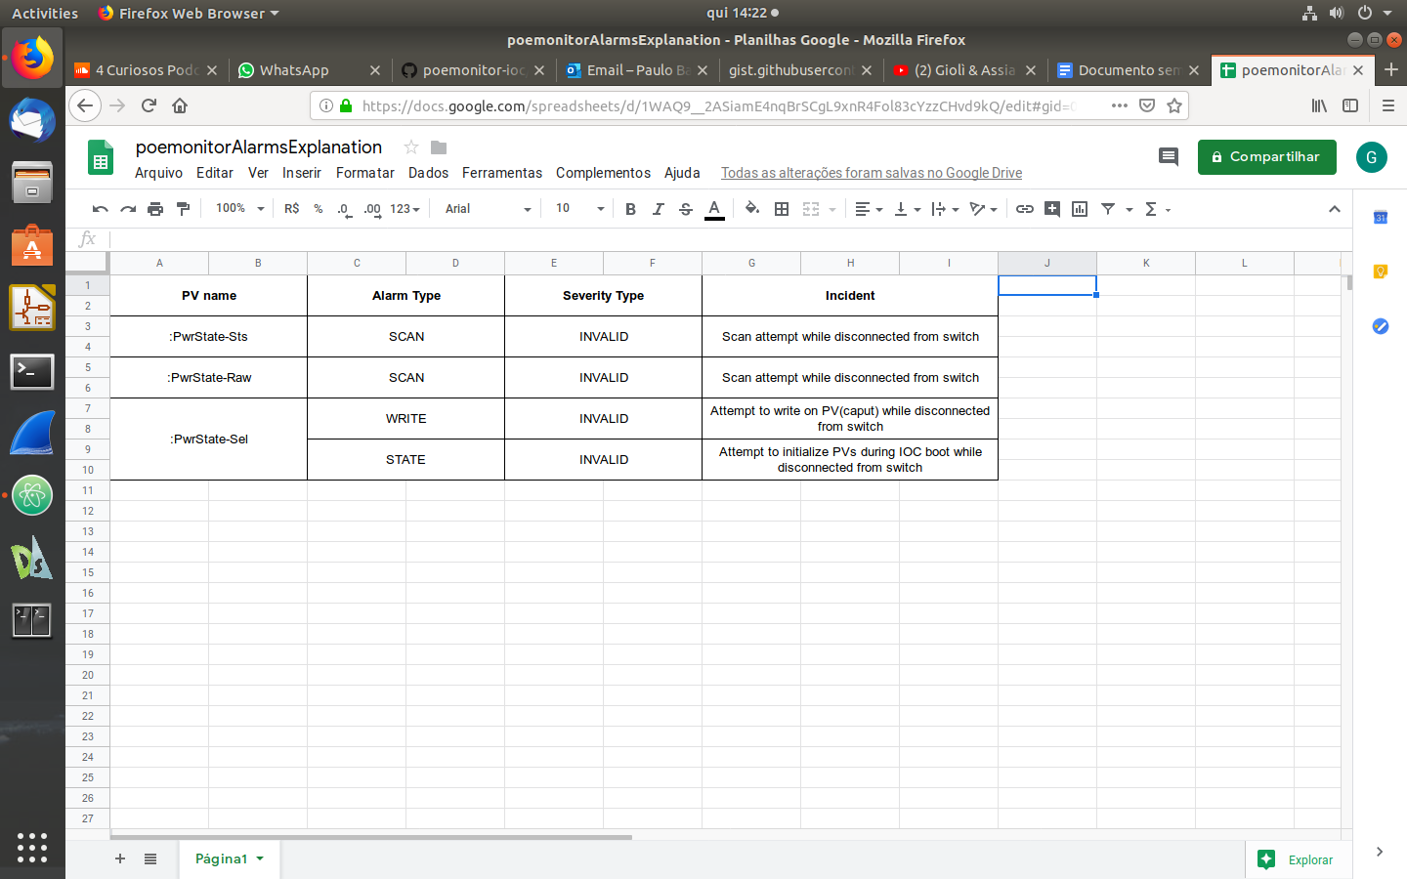

**Alarms signalization on GUI**

This section shows and explain the meaning of some situations that might appear on the GUI application. Commonly a strong pink color is used to signalize alarms.

1. **Problem on obtaining last PV values on IOC initialization**

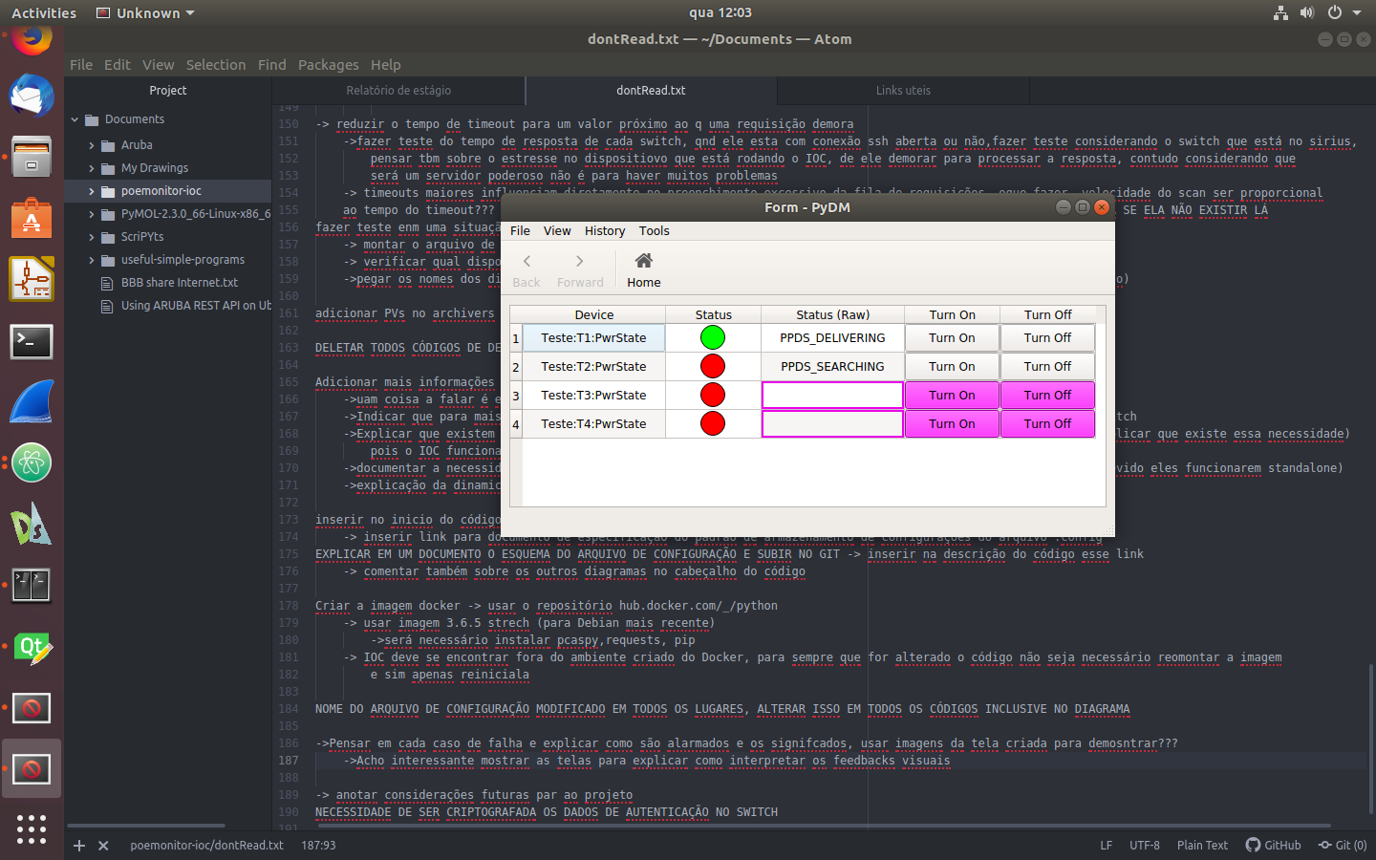

***Explanation:*** In the image above is possible to notice that there are 2 PVs (1th and 2nd) that are being monitored without any problem, and we know that exactly because there isn’t any strong pink field on their rows. On the other hand, there are 3 fields signalizing alarms on the other 2 PVs. It’s possible to notice that the “*Status (Raw)*” field has no value inside it and it’s border is colored with the strong pink alarm signalization color. **This situation happens when**, during the IOC initialization, in the process of recovering the last PV value, the IOC can’t obtain any value, resulting in a blank field signalized with the alarm color.

1. **Problem on scanning PV value**

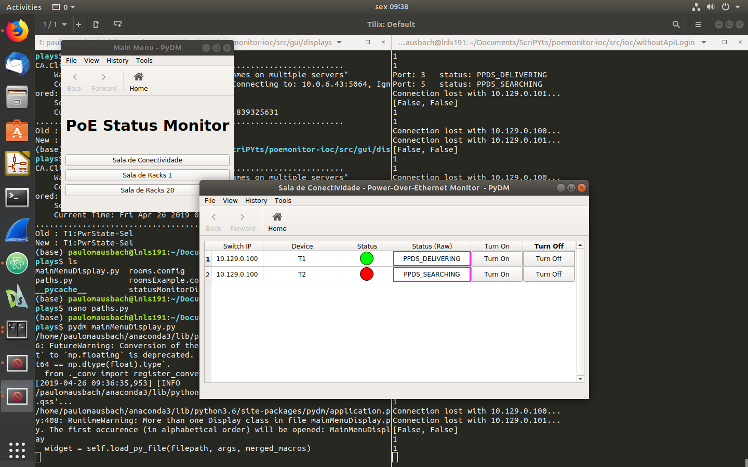

***Explanation:*** In this situation is possible to notice that the field “*Status(Raw)*” from both rows aren’t empty but their borders are colored signalizing an alarm on their values. **This situation happens when** for any reason the IOC periodically scan wasn’t able to get a new value for the PV. It’s important to notice that the “*Status*” field isn’t painted with a pink color because the PyDM widget used to represent it’s field do not have an alarm sensitive attribute, so it’s unable to signalize alarms, however the value showing still not reliable.

1. **Problem on writing PV value**

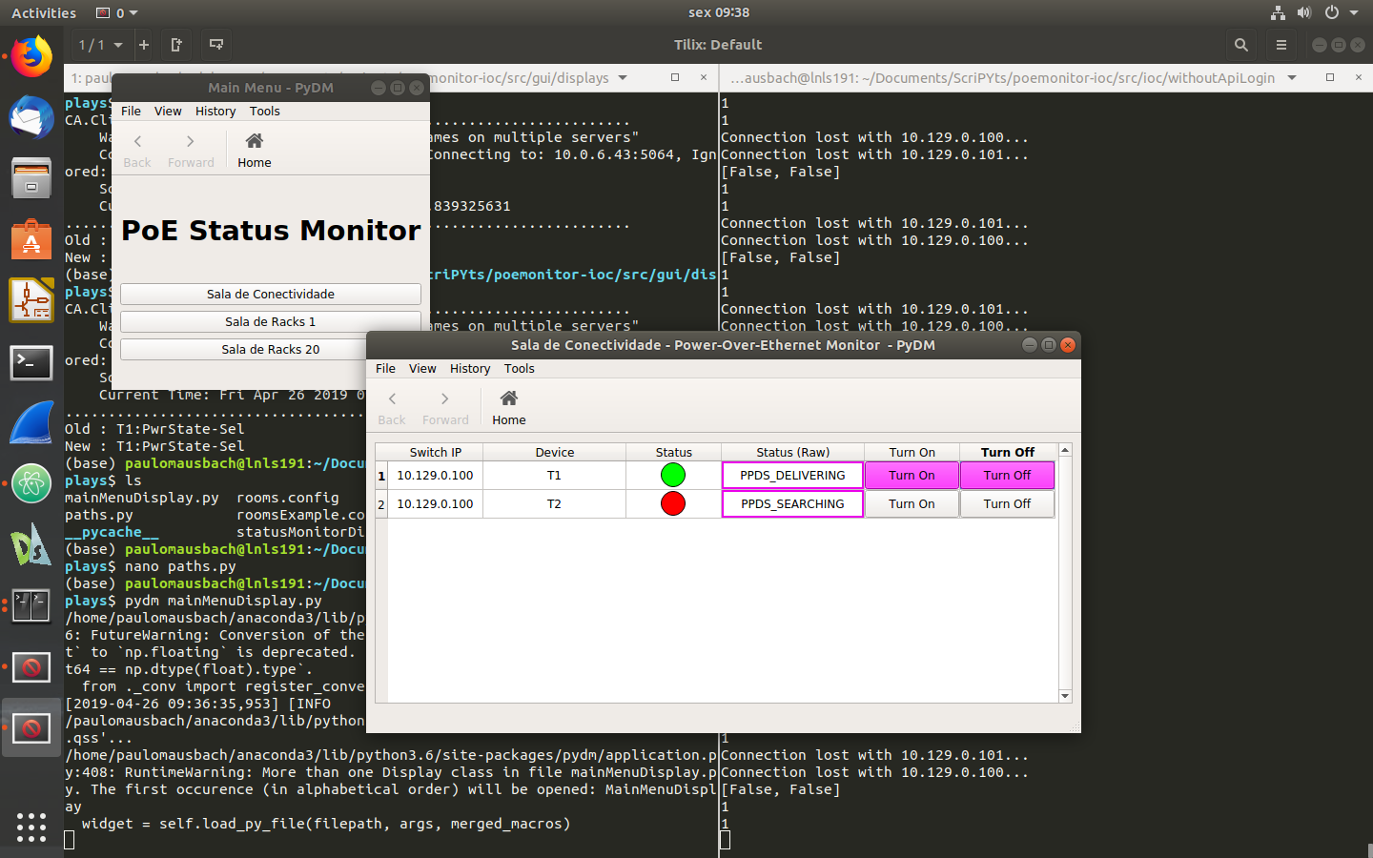

***Explanation:*** The image below is really similar to the one at topic 2 “*Problem on scanning PV value*”, the only difference is that now the buttons “*Turn On*” and “*Turn Off*” are colored with the alarm pink color as the “*Status (Raw)*” field border. **This situation happens when** the IOC can’t communicate with the PV provider and it’s tried Turn On or Off the device by the push buttons, signalizing that the operation was unsuccessful.

1. **PV reconnected but push buttons still alarmed**

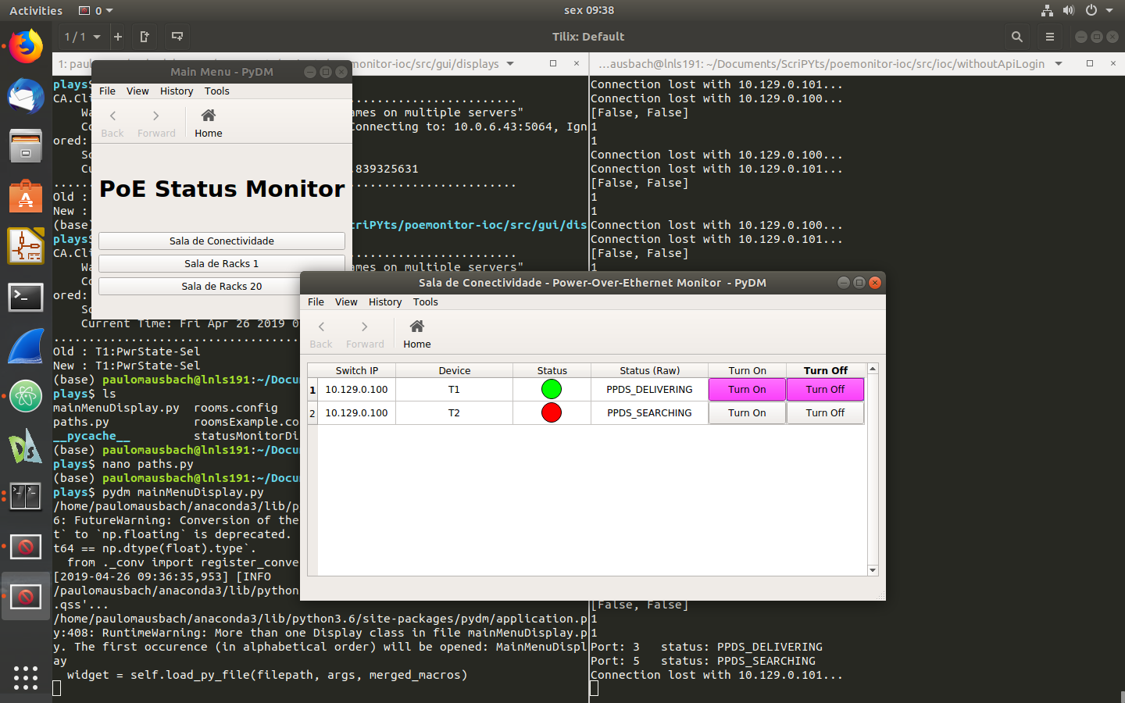

***Explanation:*** **This situation happens when** the communication with the PV provider has been restored(Easily checked as the border from the “*Status (Raw)*” field isn’t colored anymore) but the but the last try made to turn on/off so far was invalid. Both buttons fields will still colored until a valid turn on/off request isn’t make.